**AI Assisted Coding**

**Name : M.Harish**

**H.no : 2303A52387**

**Batch : 34**

**Course Code : 23CS002PC304**

**Assignment Number : 5.5**

**Lab 5**: Ethical Foundations – Responsible AI Coding Practices

**Lab Objectives:**

• To explore the ethical risks associated with AI-generated

Week3 - code.

• To recognize issues related to security, bias, transparency, and copyright.

• To reflect on the responsibilities of developers when using AI tools in software development.

• To promote awareness of best practices for responsible and ethical AI coding.

**Lab Outcomes (LOs):**

After completing this lab, students will be able to:

• Identify and avoid insecure coding patterns generated by AI tools.

• Detect and analyze potential bias or discriminatory logic in AI-generated outputs.

• Evaluate originality and licensing concerns in reused AI- generated code.

• Understand the importance of explainability and transparency in AI-assisted programming.

• Reflect on accountability and the human role in ethical AI coding practices.

**Task Description #1 (Transparency in Algorithm Optimization)**

Task: Use AI to generate two solutions for checking prime numbers:

• Naive approach(basic)

• Optimized approach

Prompt:

“Generate Python code for two prime-checking methods and explain how the optimized version improves performance.”

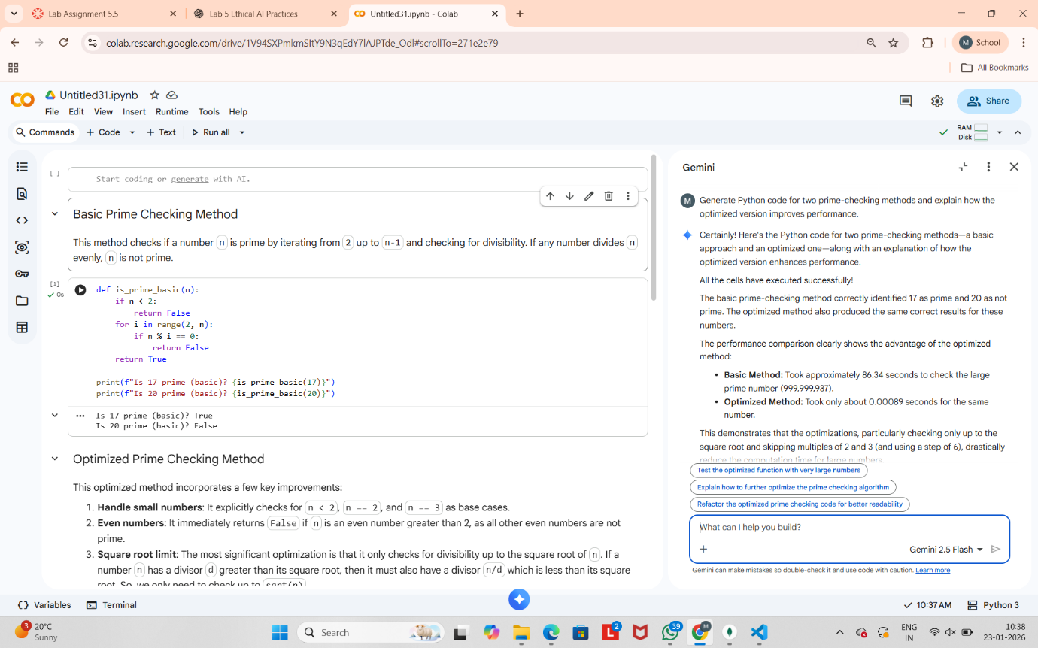

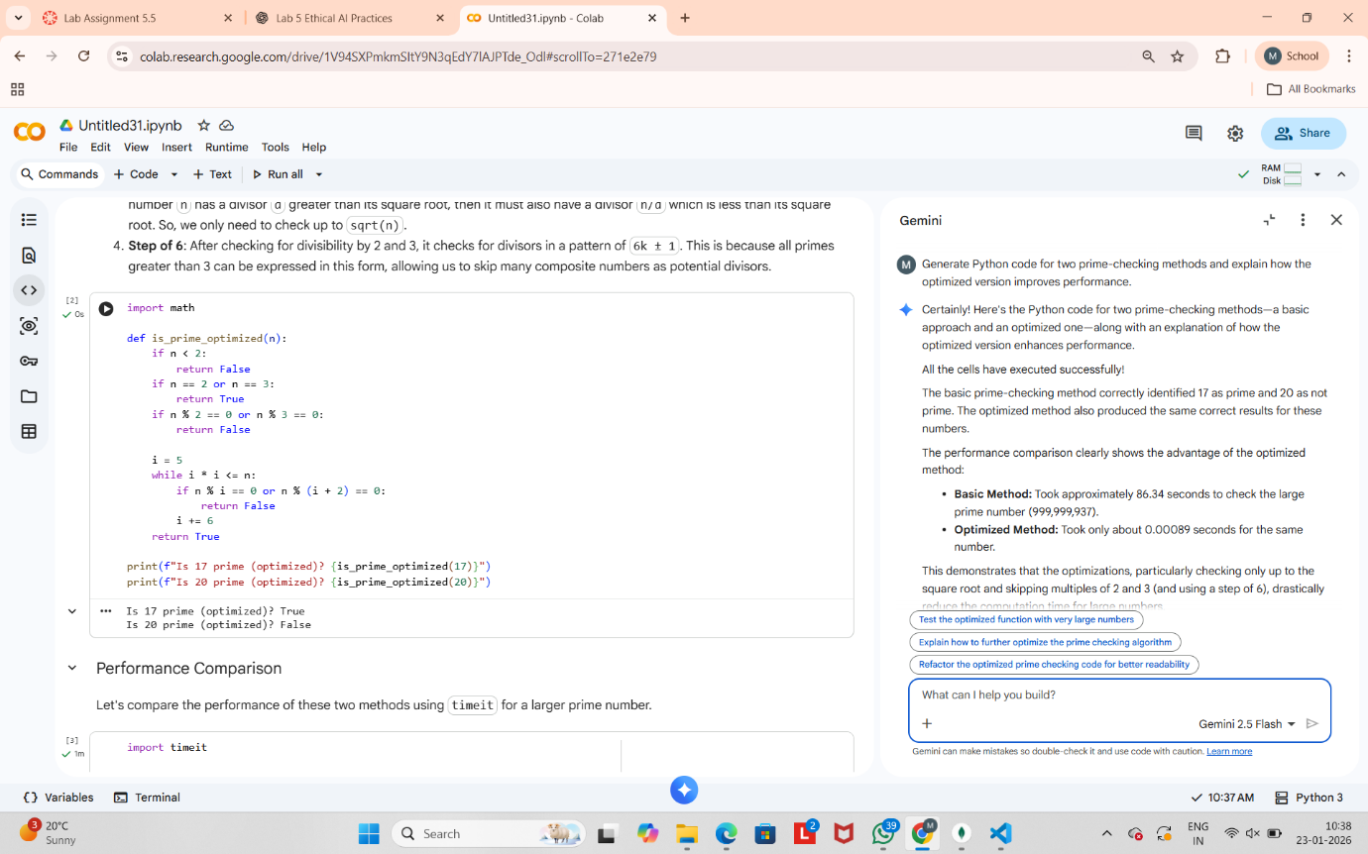

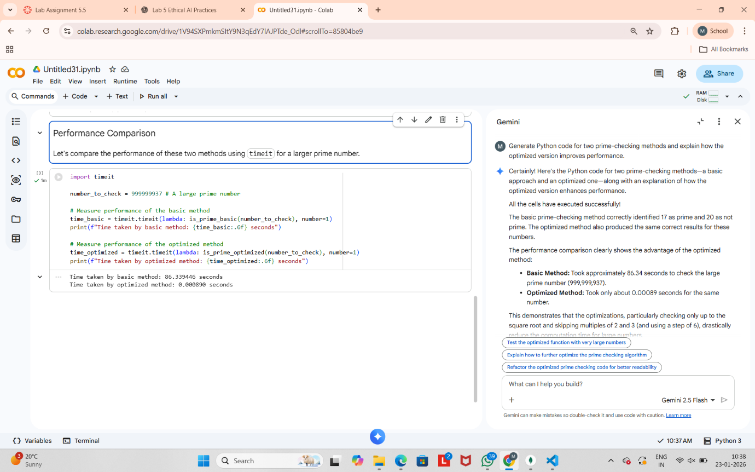

**Task Description #2 (Transparency in Recursive Algorithms)**

Objective: Use AI to generate a recursive function to calculate Fibonacci numbers.

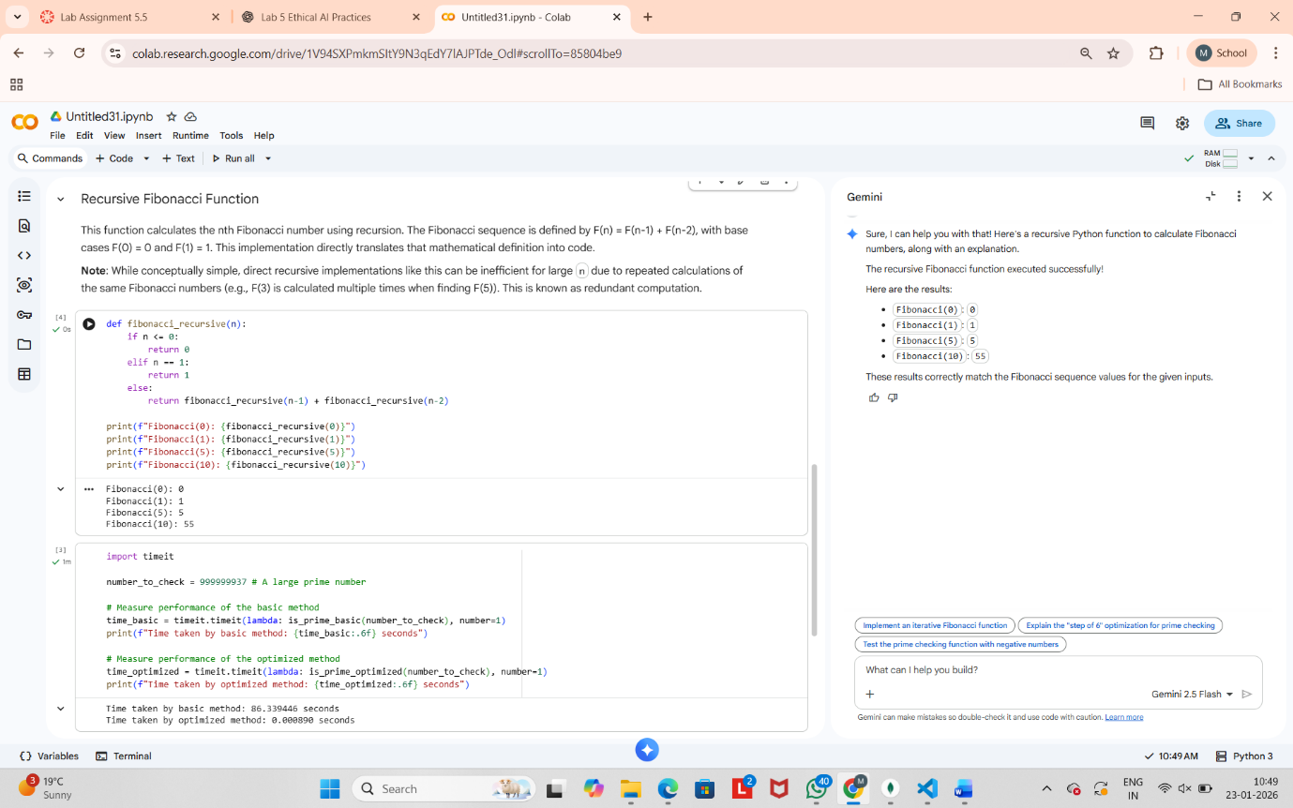

**Task Description #3 (Transparency in Error Handling)**

Task: Use AI to generate a Python program that reads a file and processes data.

Prompt:

“Generate code with proper error handling and clear explanations for each exception.

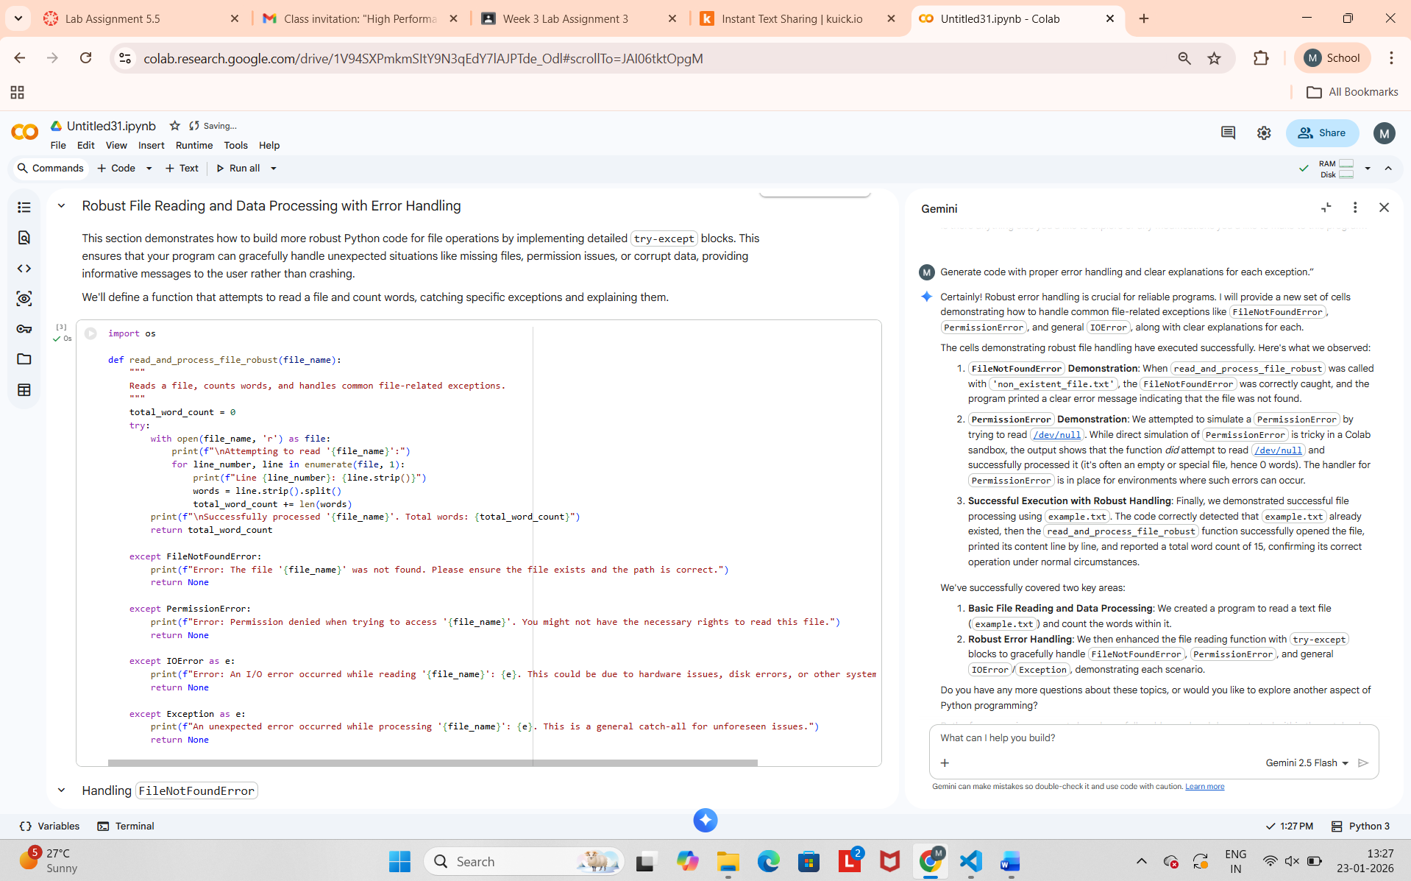

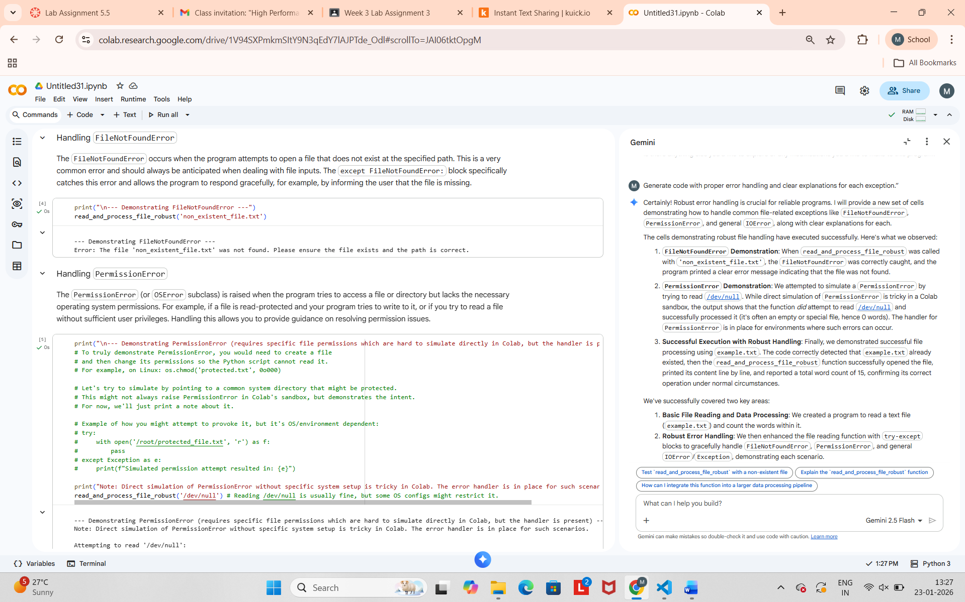

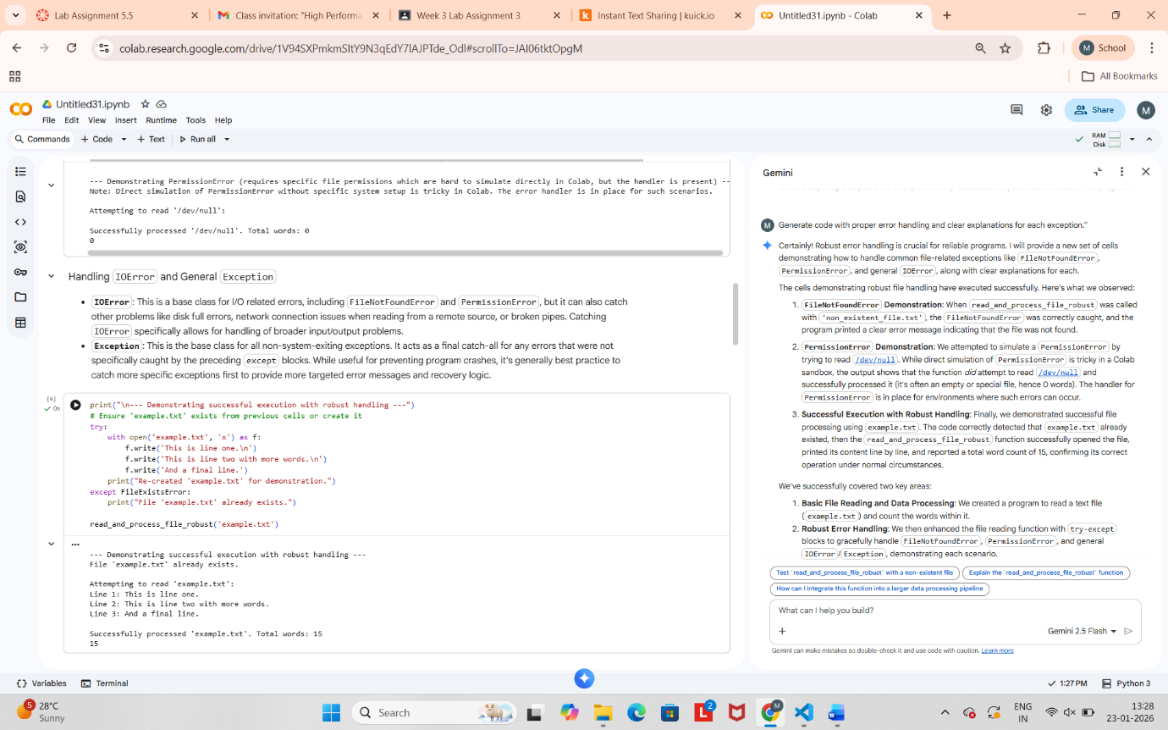

**Task Description #4 (Security in User Authentication)**

Task: Use an AI tool to generate a Python-based login system.

Analyze: Check whether the AI uses secure password handling

practices.

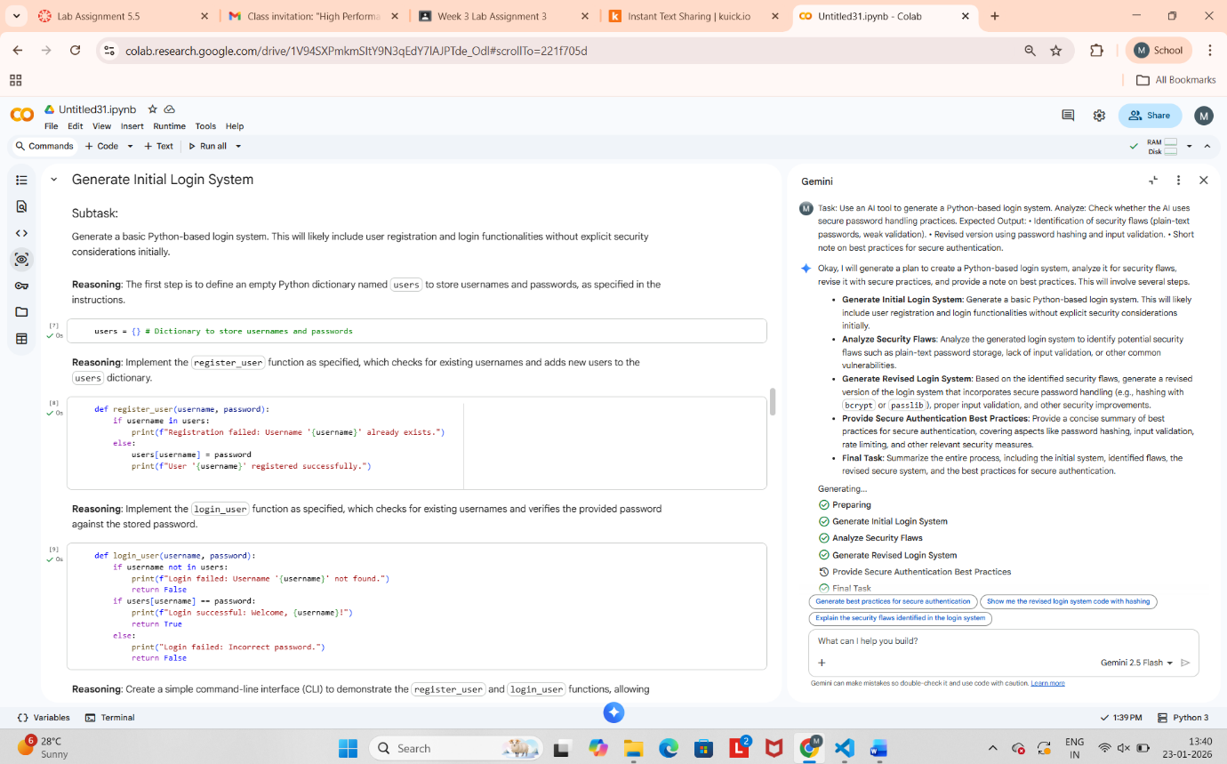

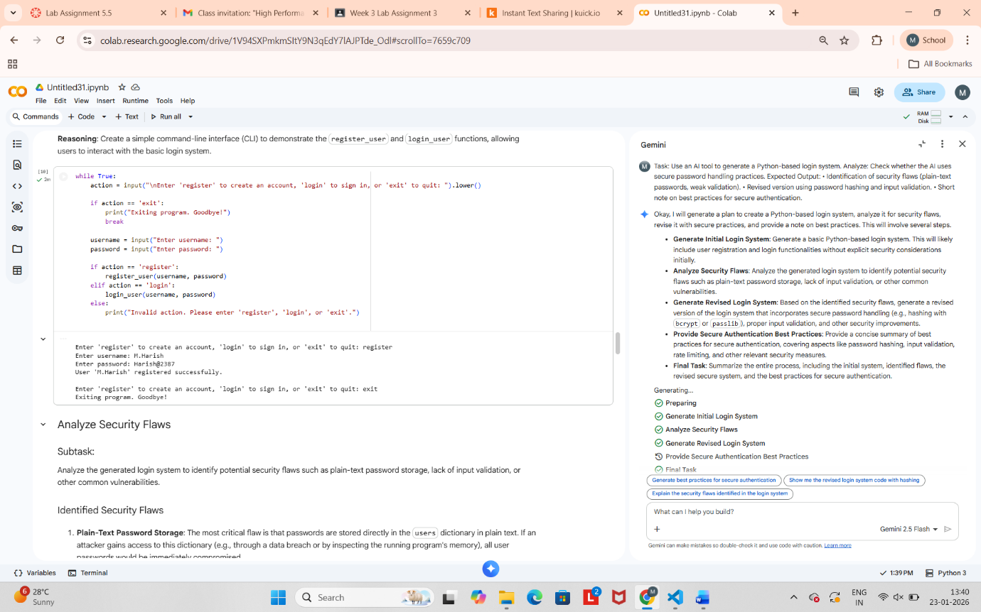

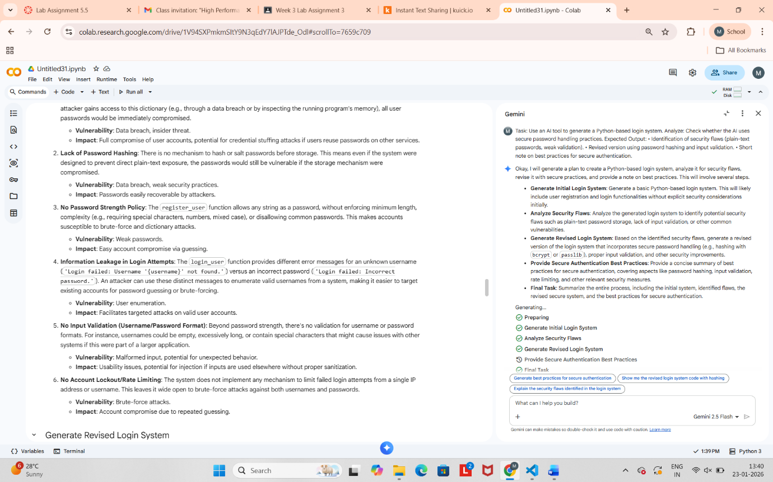



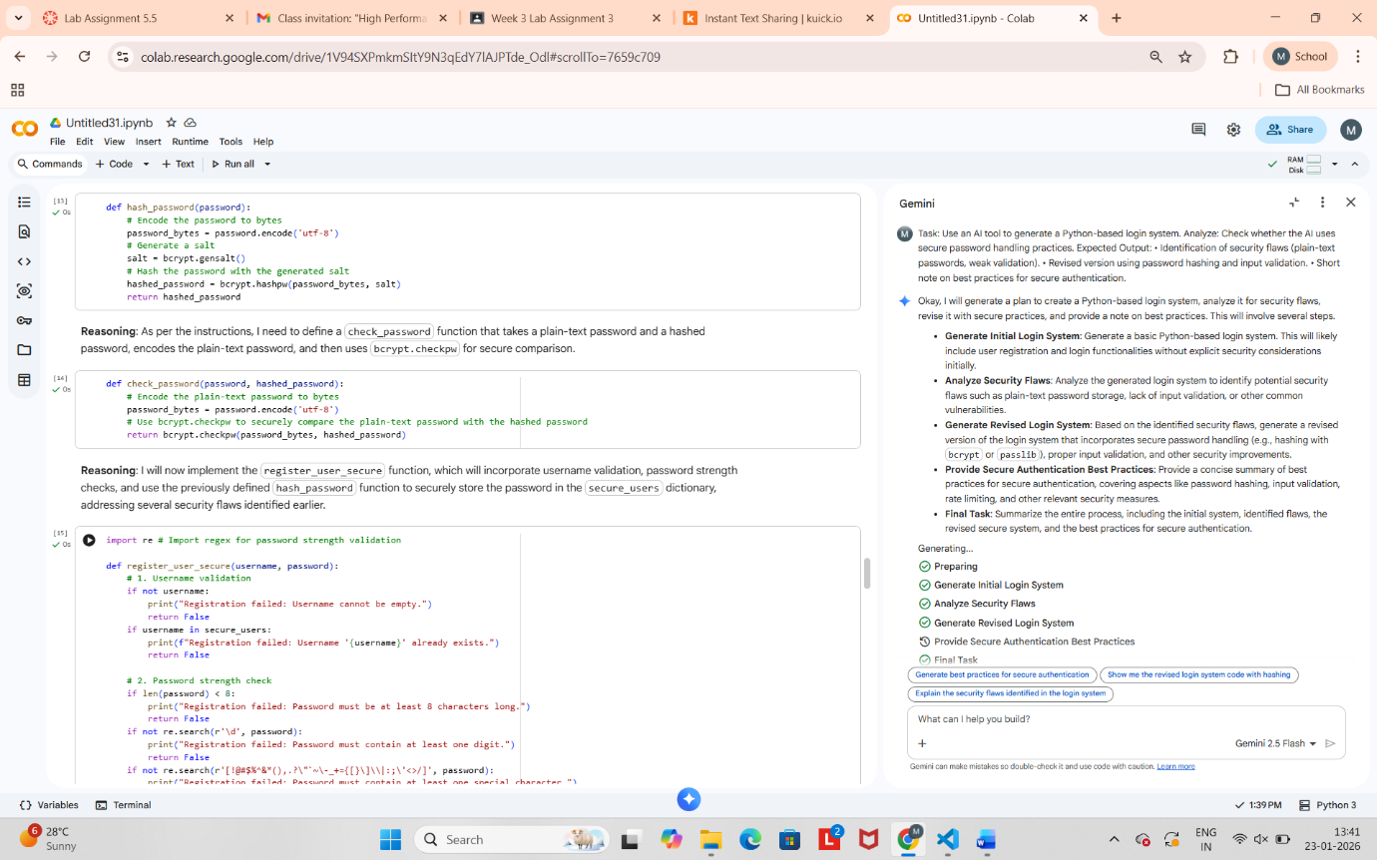

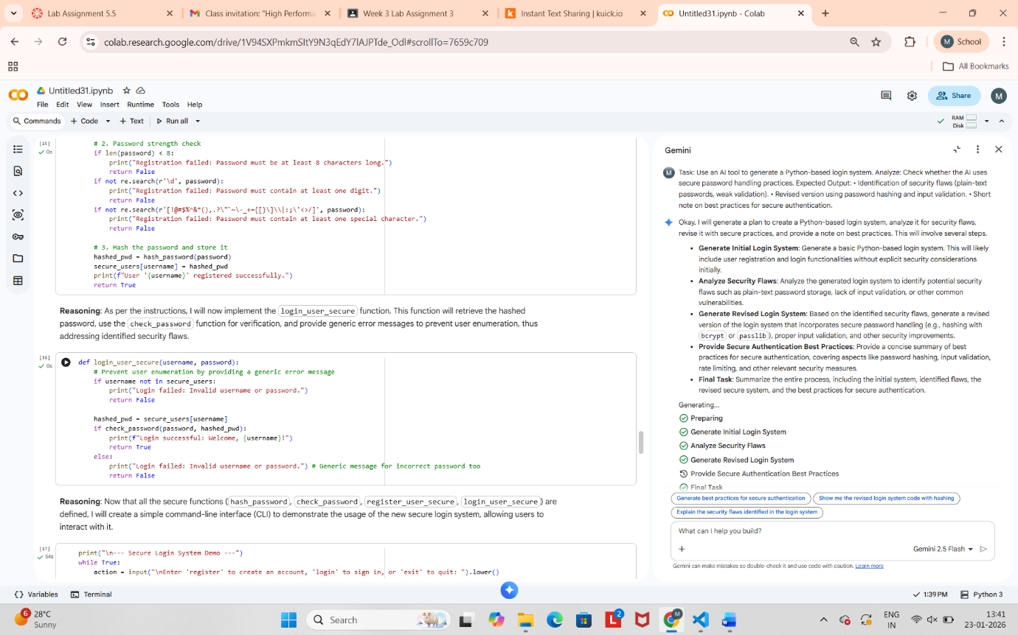

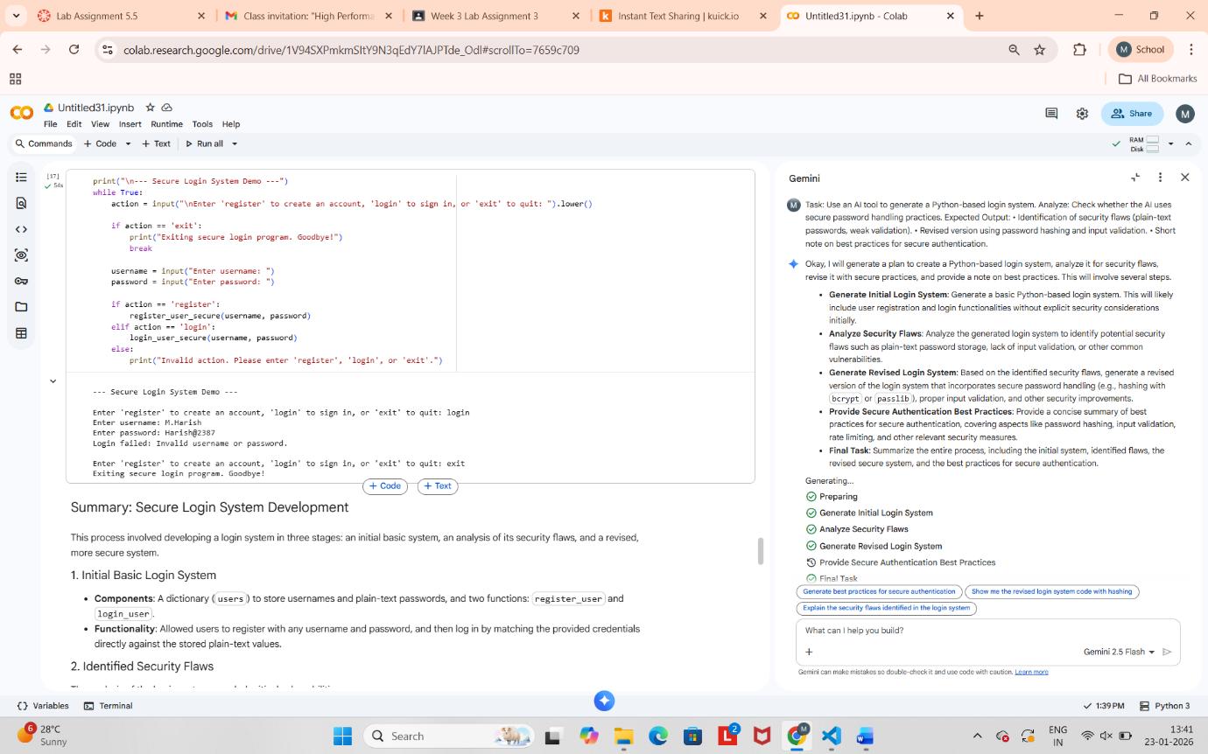

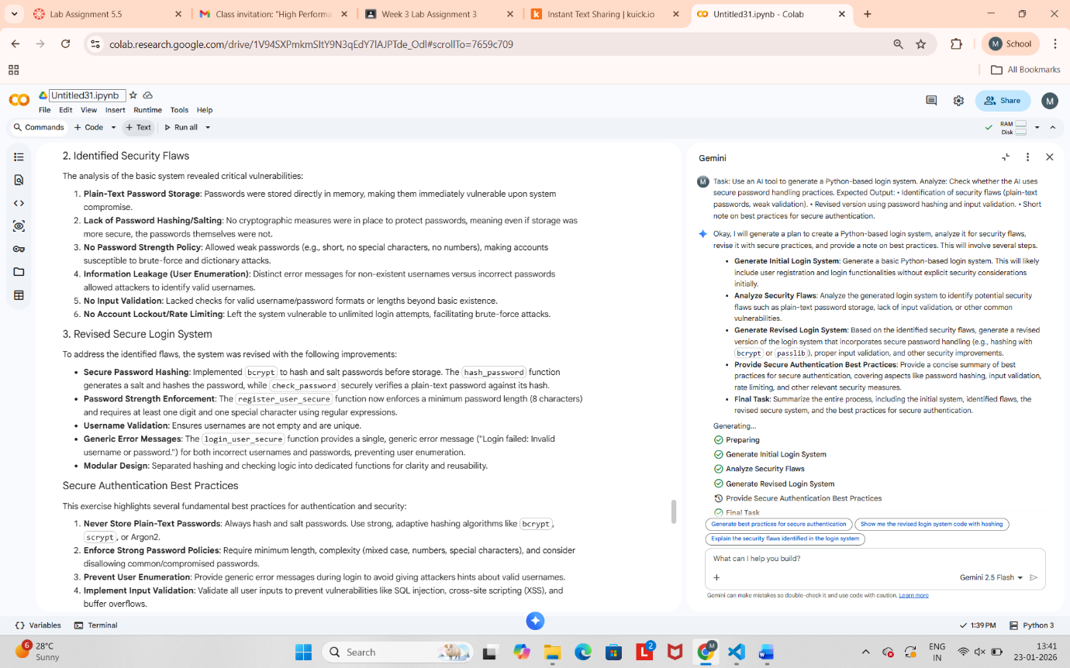

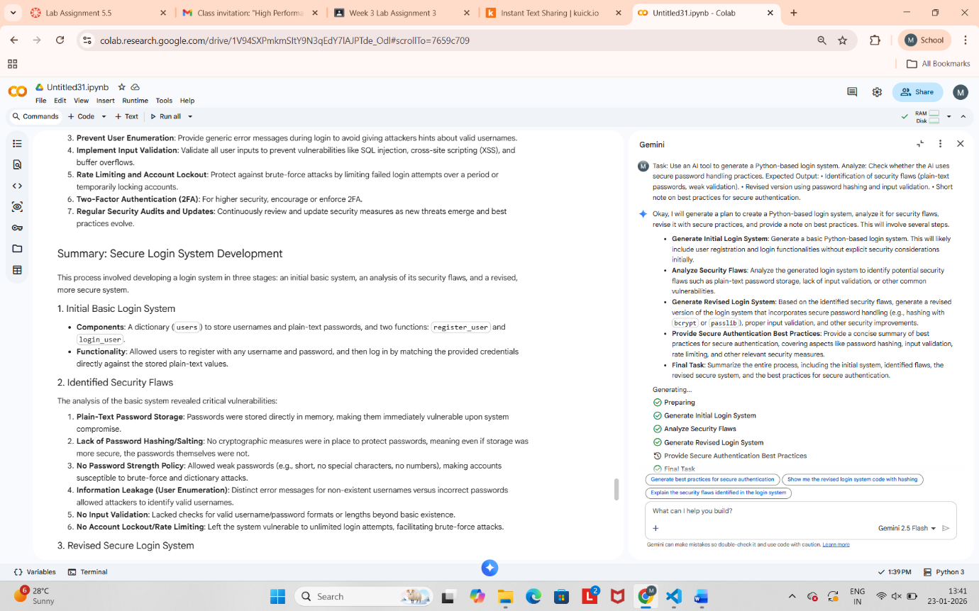

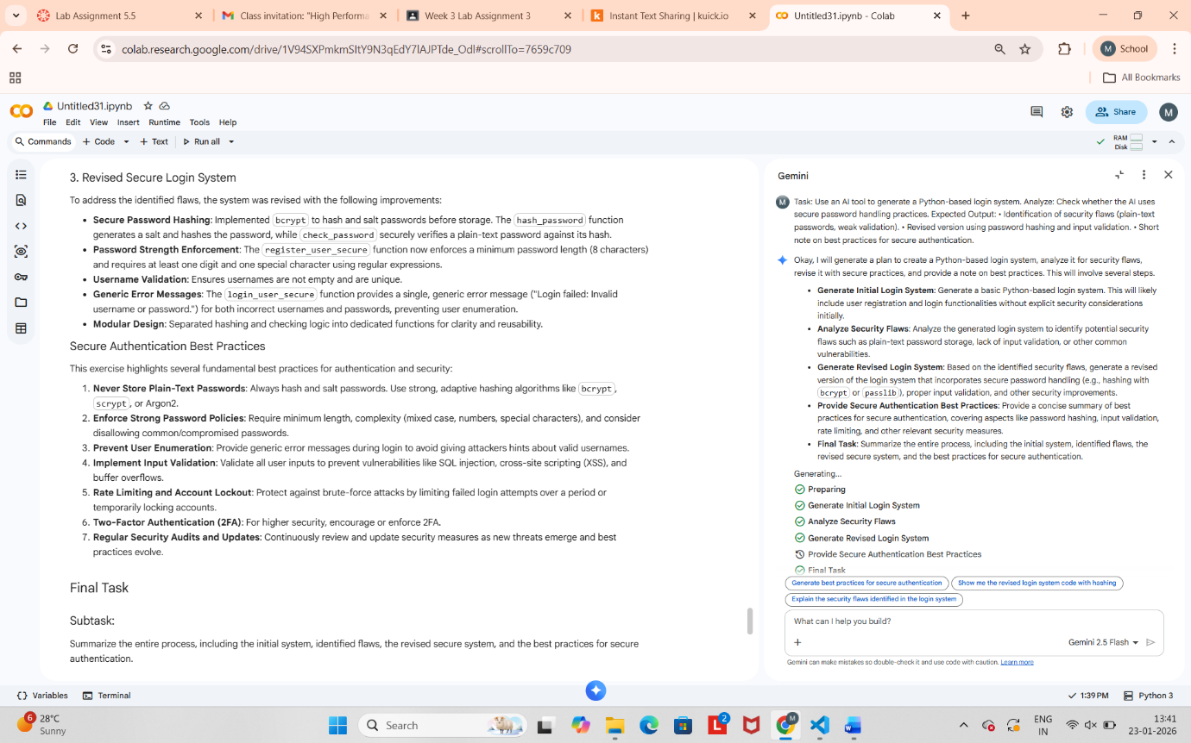

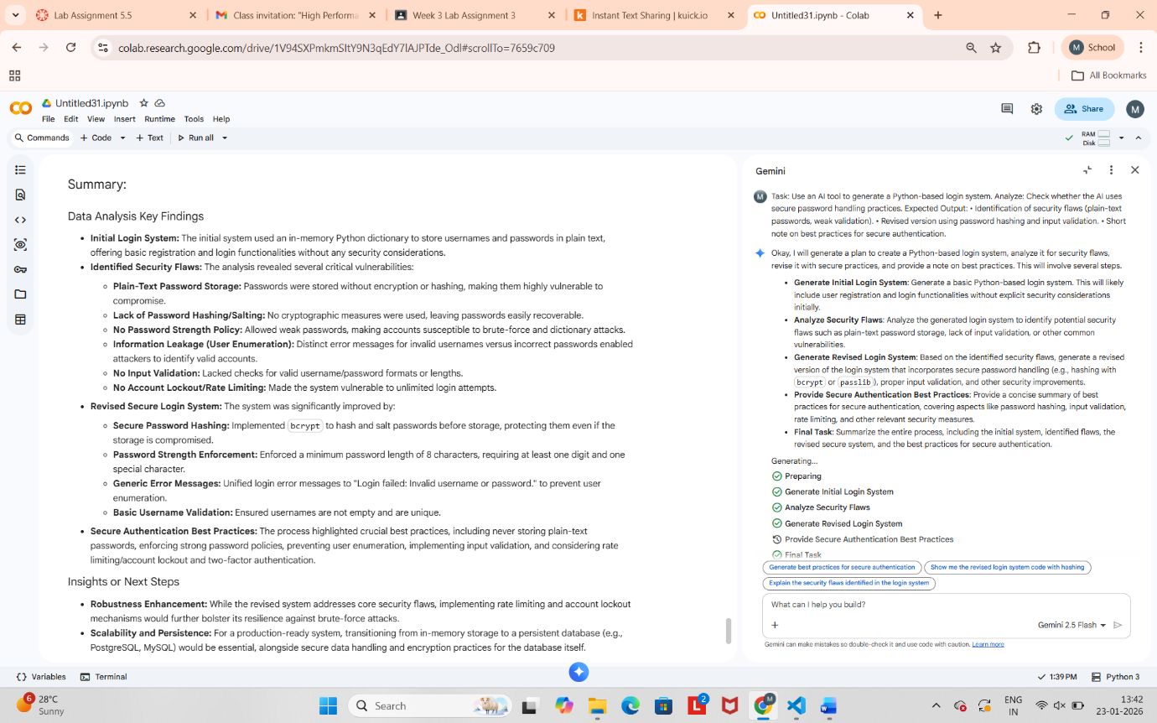

**Task Description #5 (Privacy in Data Logging)**

Task: Use an AI tool to generate a Python script that logs user activity (username, IP address, timestamp).

Analyze: Examine whether sensitive data is logged unnecessarily or insecurely.

